
PATUAKHALI SCIENCE AND TECHNOLOGY UNIVERSITY

COURSE CODE CCE 416
Network Routing and Switching Sessional

SUBMITTED TO:

Prof. Dr. Md Samsuzzaman

Department of Computer and Communication Engineering
Faculty of Computer Science and Engineering

SUBMITTED BY:
Md. Sharafat Karim
ID: 2102024,
Registration No: 10151
Faculty of Computer Science and Engineering

Lab 01
Assignment title: Basic Router Setting
Date of submission: 07 Fri, 2026

Question answers
- For the exec-timeout command, what do the 5 and 0 represent?
The 5 represents minutes and the 0 represents seconds of inactivity before the session times out.
- What would be the result of reloading the router prior to completing the copy running-config startupconfig command?
All configuration changes stored only in the running configuration (RAM) would be lost because they were not saved to the startup configuration
- Were the pings successful?
Yes, they were. As I configured PC-A and PC-B beforehand.
- After completing this series of commands, what type of remote access could be used to access R1?
Telnet
- Was remote access successful?
Yes
- Why is the Telnet protocol considered to be a security risk?
It uses plaintext, even for password.
- Was remote access successful?
Yes, they were.
- What is the name of the IOS image that the router is running?
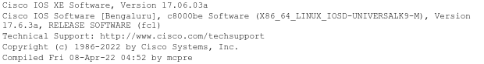
- How much non-volatile random-access memory (NVRAM) does the router have?
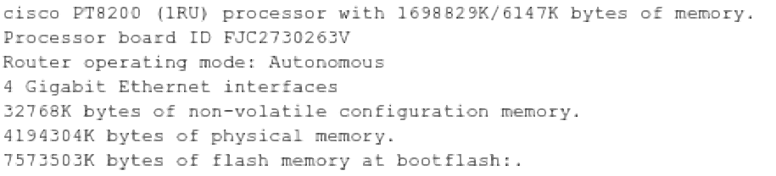
- How much Flash memory does the router have?
7573503K bytes
- What is the boot process for the router on the next reload?
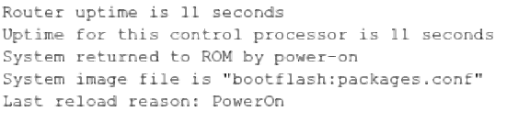
- How are passwords presented in the output?
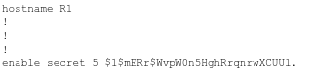
- What is the result of using this command (show startup-config | begin vty)?
Invalid command
- What code is used in the routing table to indicate a directly connected network?
C
- How many route entries are coded with a C code in the routing table?
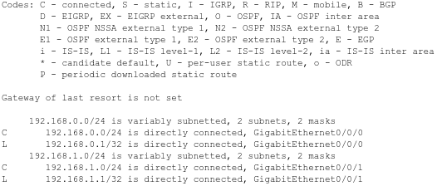
2 routes
- What command changed the status of the Gigabit Ethernet ports from administratively down to up?
no-shutdown
- If no IPv6 address is assigned to G0/1, why is it listed as [up/up]?
It’s connected to a IPv4 and manually set to up earlier.
- What is the IPv6 address assigned to PC-B?
2001:db8:acad:a::3
- What is the default gateway assigned to PC-B?
2001:db8:acad:a::1
- Issue a ping from PC-B to the R1 default gateway link local address. Was it successful?
yes, it was
- Issue a ping from PC-B to the R1 IPv6 unicast address 2001:db8:acad:a::1. Was it successful?
yes it was
- In researching a network connectivity issue, a technician suspects that an interface was not enabled. What show command could the technician use to troubleshoot this issue?
show ip interface brief
- In researching a network connectivity issue, a technician suspects that an interface was assigned an incorrect subnet mask. What show command could the technician use to troubleshoot this issue?
show interfaces
- After configuring IPv6 on the R1 G0/0 PC-B LAN, if you were to ping from PC-A to the PC-B IPv6 address,would the ping succeed? Why or why not?
Yes, it was successful, cause router is translating IPv4 to IPv6

